Academic Year: 2024-25 | Year: First Year | Term: I
Roll No.: | 11
Name: | Riddhee Sandeep Kulkarni
Subject: FCP
Assignment No.: | 27
Title: | Complex Number Operations
Date:

Contents
1. Theory (Logic) 2
2. Pseudo Code 2
3. Program Code 2
4. Output 2
5. Conclusion 2

THEORY:

This code displays addition and multiplication of complex numbers using structures.

PSEUDO CODE:

Step 1: Start

Step 2: define structure

Step 3: define main function

Step 4: enter values of complex numbers

Step 5: execute addition and multiplication

Step 5: print output

Step 6: end

PROGRAM CODE:

#include <stdio.h>

struct Complex

{

};

f

loat x;

f

loat y;

struct Complex addComplex(struct Complex c1, struct Complex c2)

{

}

struct Complex result;

result.x = c1.x + c2.x;

result.y = c1.y + c2.y;

return result;

struct Complex multiplyComplex(struct Complex c1, struct Complex c2)

{

}

struct Complex result;

result.x = c1.x * c2.x - c1.y * c2.y;

result.y = c1.x * c2.y + c1.y * c2.x;

return result;

int main()

{

struct Complex num1, num2, sum, product;

printf("Enter the x (real part) and y (imaginary part) of the first complex number:\n");

scanf("%f %f", &num1.x, &num1.y);

printf("Enter the x (real part) and y (imaginary part) of the second complex number:\n");

scanf("%f %f", &num2.x, &num2.y);

sum = addComplex(num1, num2);

product = multiplyComplex(num1, num2);

printf("\nResults:\n");

printf("Sum: %f + %fi\n", sum.x, sum.y);

printf("Product: %f + %fi\n", product.x, product.y);

return 0;

}

OUTPUT:

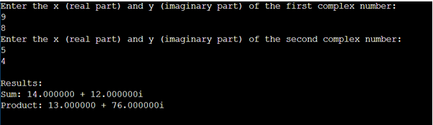

CONCULSION:

Code is run successfully, required output received

